Assessed Practical 1: Lost in Space

1a)   
During the re-entry phase, the lander should have started with an initial velocity of around 12 km/s (12,000 m/s) before air friction slowed down the craft to a speed of a few hundred meters per second (m/s). This phase should last approximately 12 minutes.

All output and graphs seen throughout this report were created using Python.

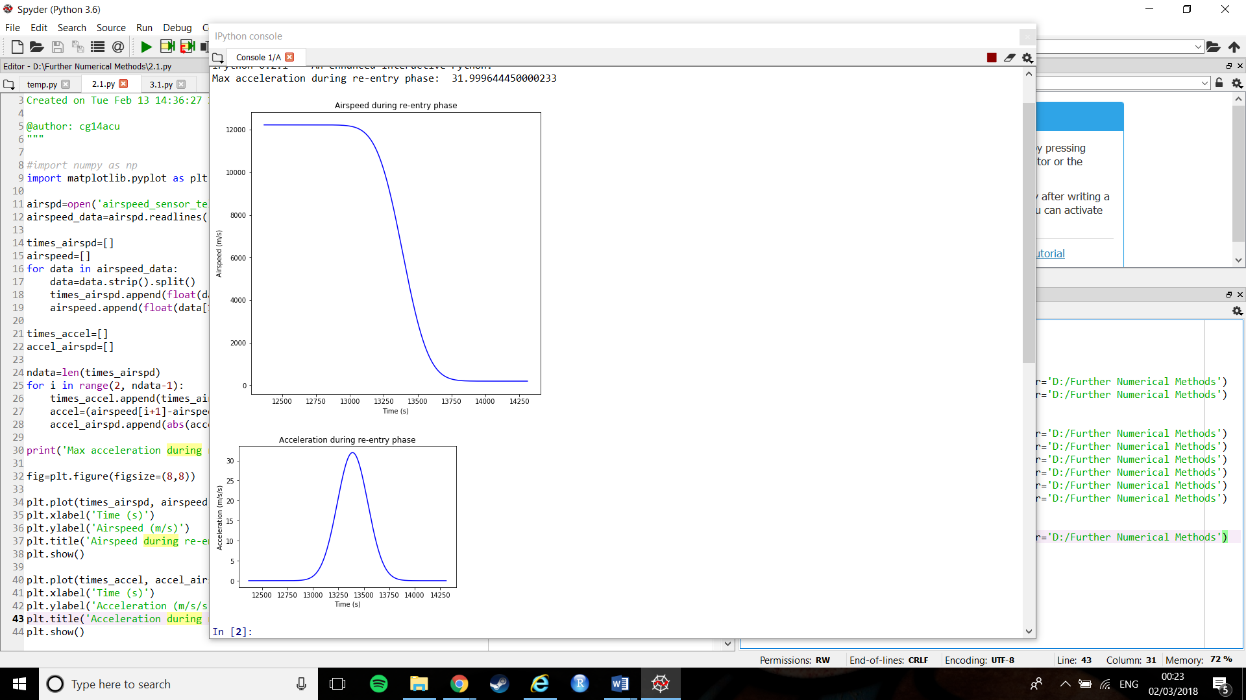

Figure : Lander's Velocity over Time

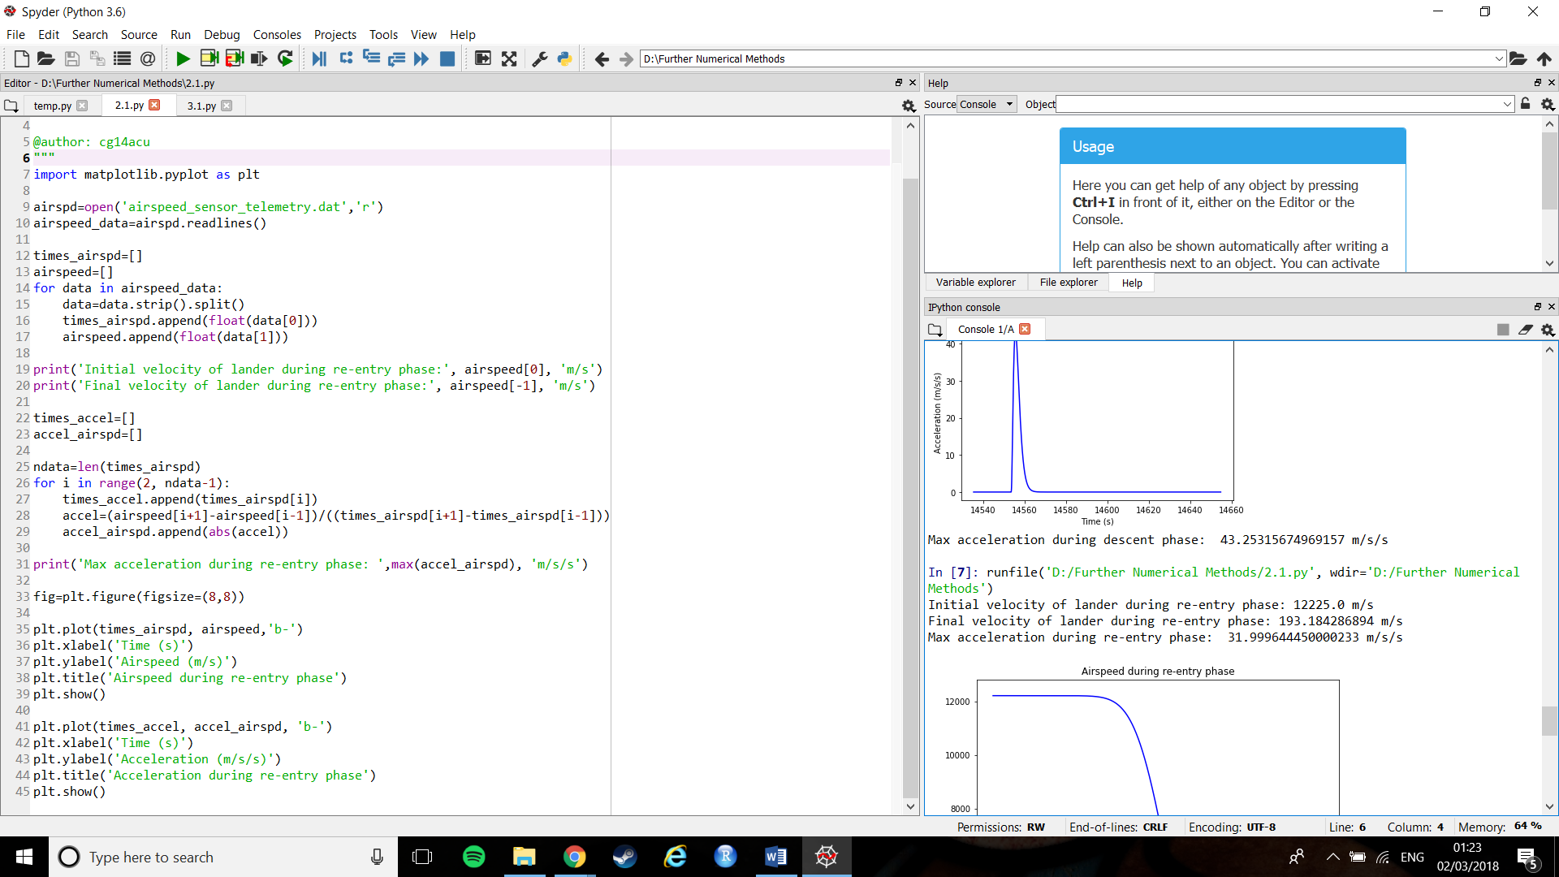

Figure : Final and Initial velocities of the lander

As we can see the lander entered Mars’ atmosphere travelling at a speed of 12225 m/s, slightly faster than the 12000 m/s anticipated, but not fatally. The lander then slowed down to 193.18 m/s as desired.

Judging from the graph, the time taken for this reduction in velocity was approximately 750 seconds. The ideal length of time was 12 minutes, or 720 seconds, so again our lander’s value was slightly off of the ideal value. This is in keeping with the fact that the lander entered Mars’ atmosphere at a slightly faster velocity (entering at a faster velocity would mean the lander should take longer to slow down to the desired velocity).

1b)   
It is important that throughout the course of the landers descent to Mars (Phase 1 and 2 conbined), the acceleration of the lander never increases above 35 m/s as it would likely damage its system.



Figure : Acceleration experienced by the lander in the First Phase

Figure : Maximum acceleration during the first phase

From the graph (Figure 3) we can see that the lander’s acceleration reaches above 30m/s but is unclear as to the exact value it. To aid the analysis, the largest value in the list of acceleration values was printed: 32m/s2. This is safely below the danger zone of 35m/ s2.

2a)   
Between the first and second phase, the lander transitions to vertical descent. Once this has been achieved, the second phase begins, and a laser altimeter starts measuring the landers height every 10 seconds.

Ideally, the altimeter should switch on once the lander has reached a height of 7500m above the surface of Mars.

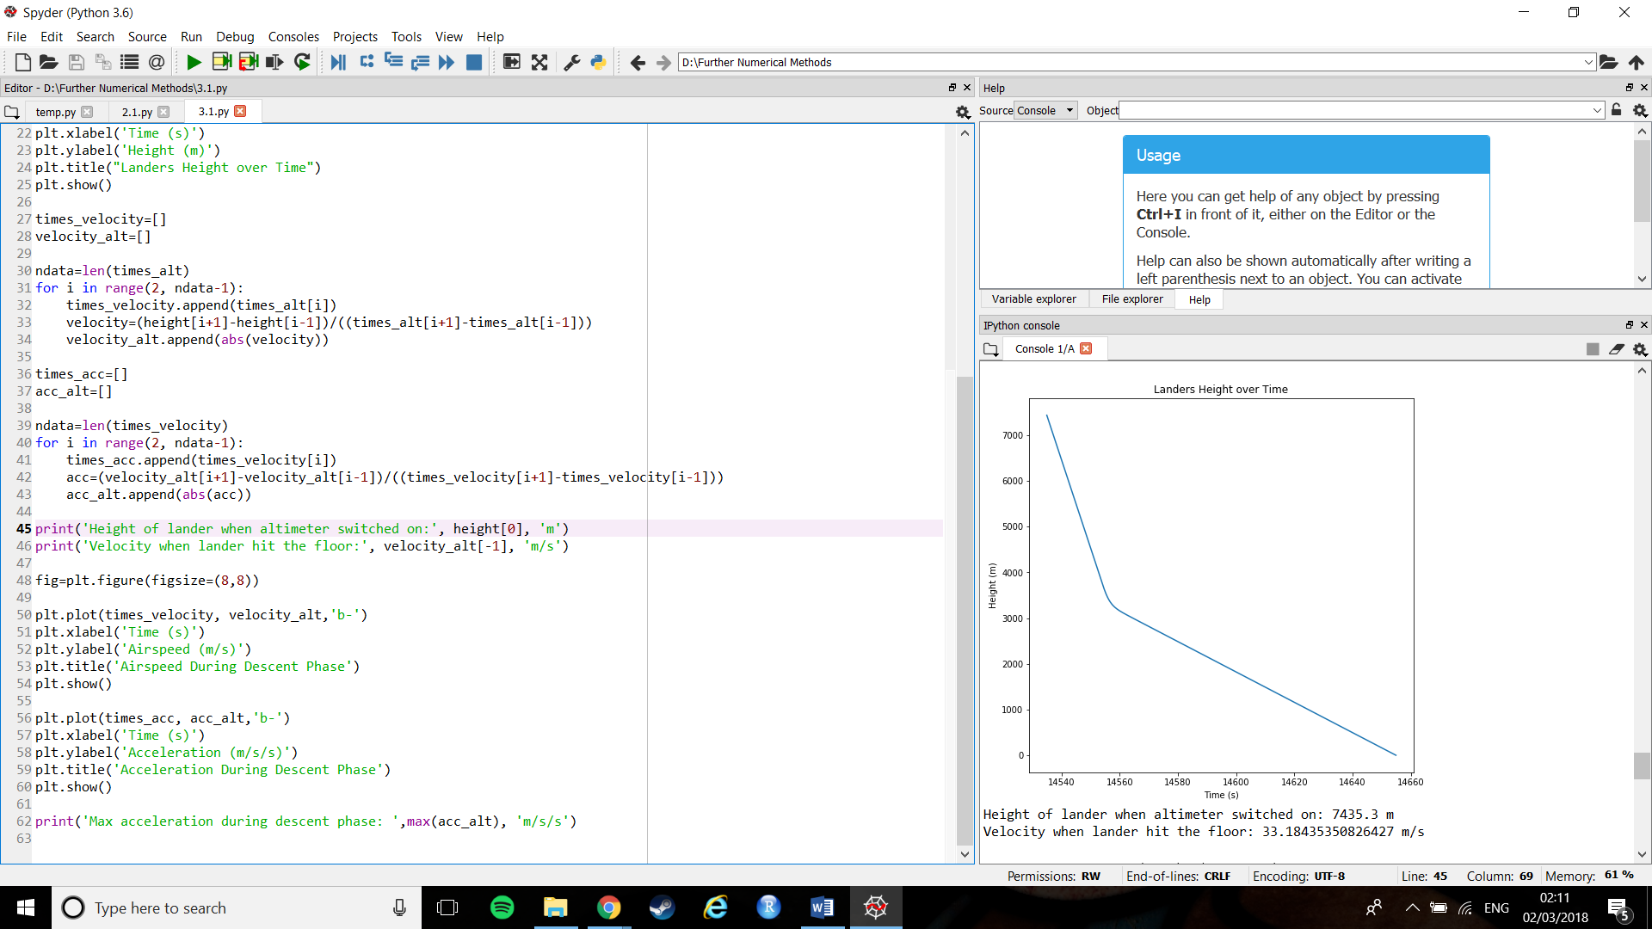

Figure : Lander’s height over time



Figure : Height of lander when altimeter turned on

As can be seen in figure 5, the altimeter did switch on around the 7500m mark, however we cannot see precisely when. Again, to ensure an accurate analysis, the actual value was printed, as can be seen in figure 6.

The precise height of the lander at the time which the altimeter was turned on was 7435.3m, slightly lower than the 7500m, but not enough to be a problem. This is in keeping with what we see from our results for 1b), in that the lander took slightly longer to reach the correct velocity to begin the transfer to vertical descent.

2b)   
About 20 seconds after the altimeter begins recording, the lander’s parachute should open, reducing its velocity to around 30m/s. It should remain at this speed until the last 20m, which should be controlled by rocket motors.

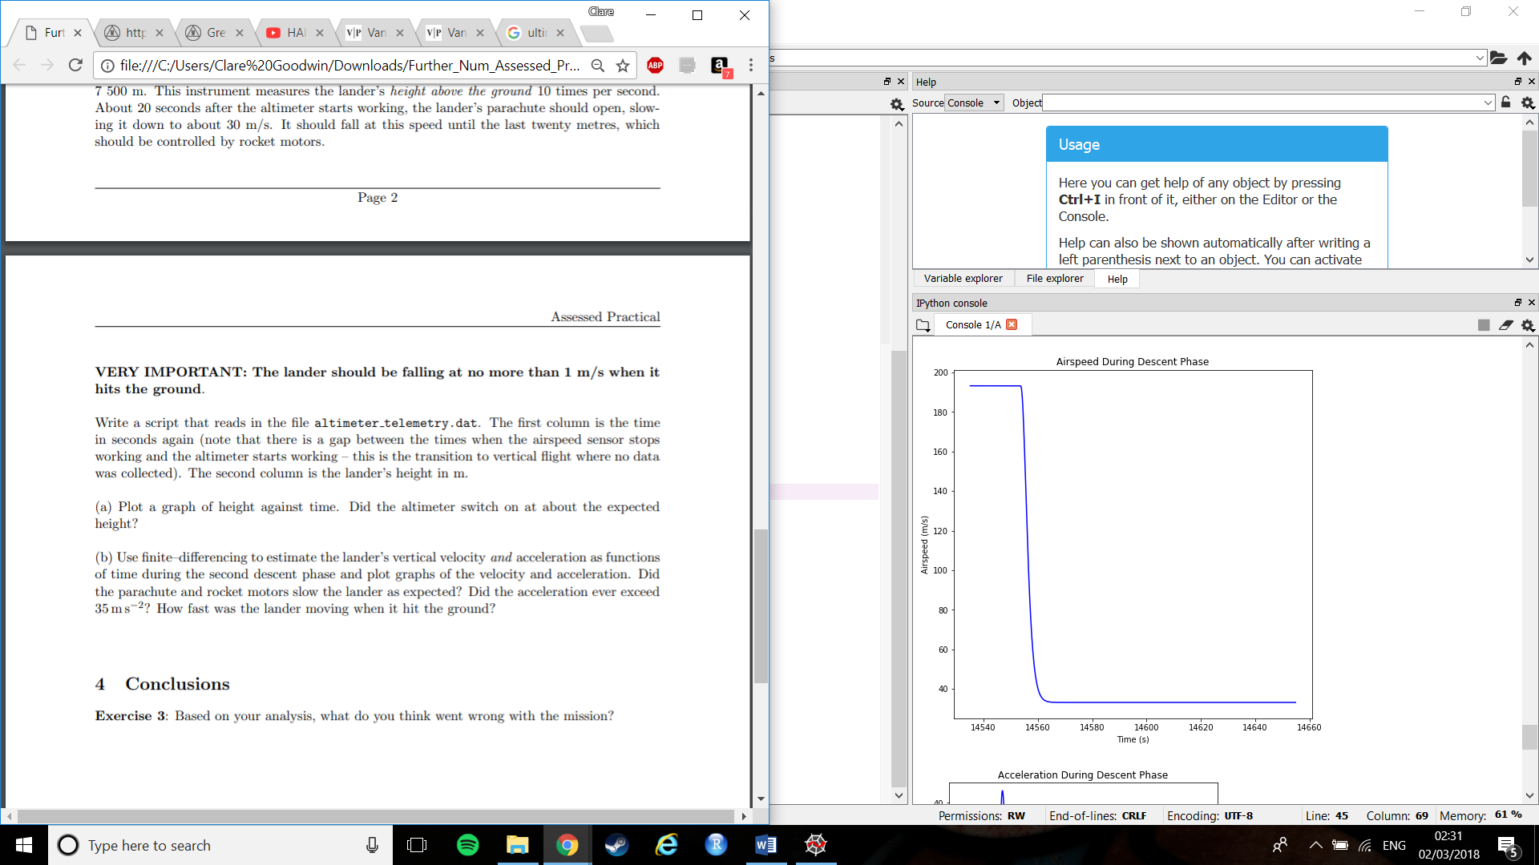

Figure : Airspeed of lander during phase two

From figure 7, we can see that the lander started this phase travelling just under 200m/s. Then, after about 20 seconds, there is a sharp decrease. This can be assumed to be the parachute deploying as intended. However, this seems to be the only change in velocity shown, suggesting that the rocket motors did not slow the lander further.

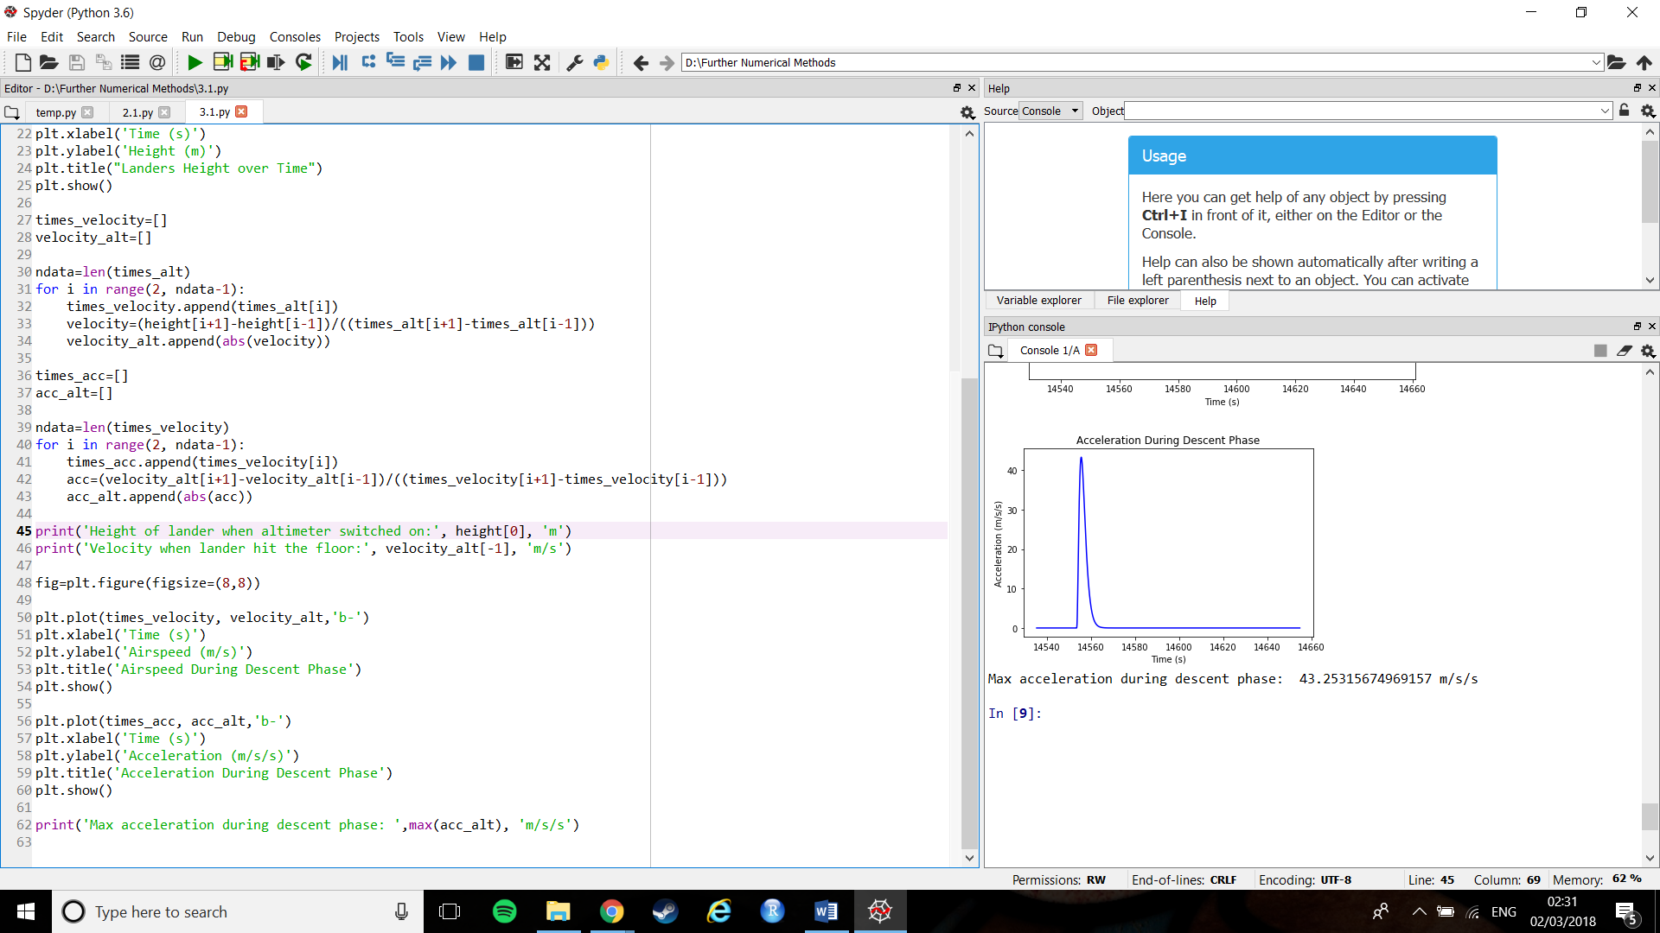   
Figure : Acceleration of the lander during phase two

Figure 8 also shows a sharp change at the same point, again showing that the parachute did in fact deploy at the correct time. However, this is the only time where there is any change in acceleration. Again, this is not what would be expected if the rocket motors had acted as desired.



Figure : Maximum acceleration of the lander during phase two

From figure 9 we can see that the maximum acceleration reached 43m/s2. This is above 35m/ s2, the level at which we run the risk of damaging some of the lander’s systems.

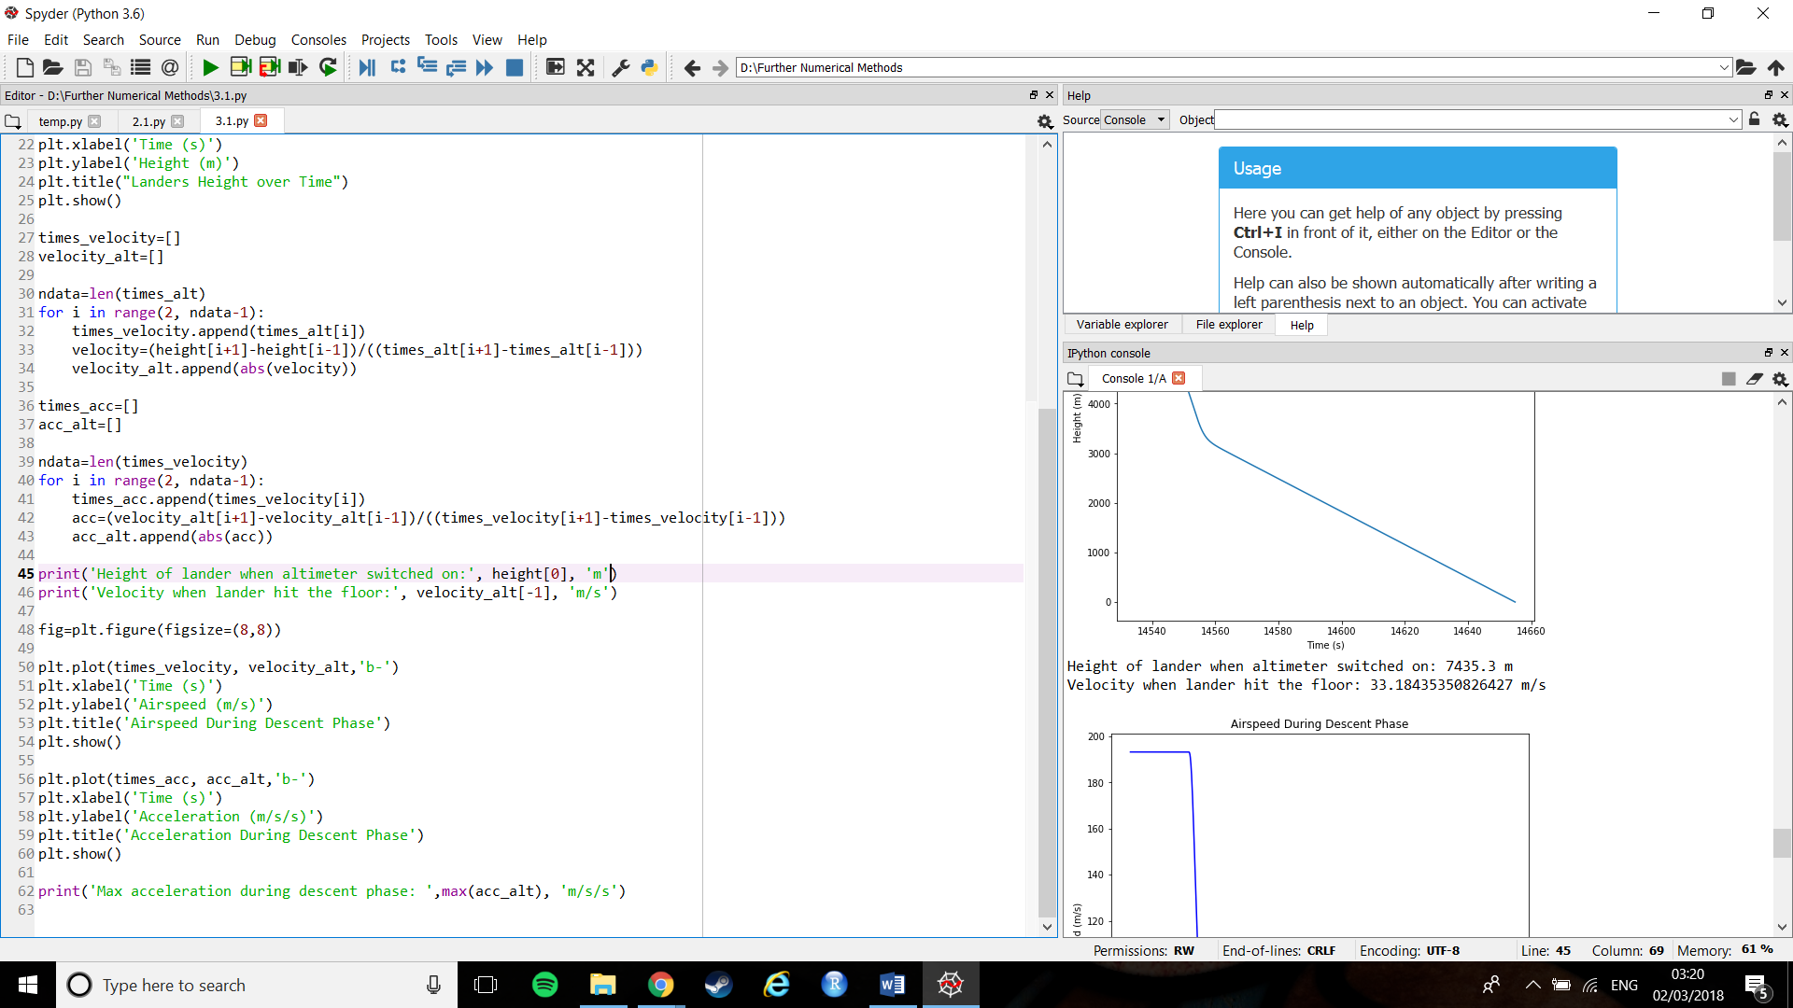

Figure : Velocity of the lander when it hit Mars' surface

From figure 10, the lander reached the surface of Mars at 33m/s. Far above the 1m/s it should not have exceeded.

3)   
Looking at the analysis above, it is clear that nothing went wrong during the first phase of the lander’s descent to Mars’. During this phase it never accelerated above the 35 m/ s2 threshold and slowed down to the specified ‘few hundred meters per second’ in the correct amount of time.   
However, looking at the second phase shows a host of problems. Clearly the lander hit the ground at far too fast a speed: 33m/s as opposed to less than 1m/s. Looking at the graphs in figures 7 and 8 they seem to suggest this is because there was no further reduction in speed after the initial burst from the parachute. This would seem to imply that the rocket motors did not fire.  
This brings about the question as to why the rocket motors not perform. Looking at figures 8 and 9 shows us that the lander hit an acceleration of 43 m/ s2 during the vertical descent phase. It was, however, imperative that the lander did not experience acceleration above 35 m/ s2 as it would likely damage some of its systems (such as the one controlling the deployment of the rocket motors).  
In brief: during the vertical descent phase, the parachutes deployed as normal, however it caused the lander to reach an acceleration of 43 m/ s2, damaging some of its systems and stopping the motor rockets from deploying, causing the lander to crash into the surface of Mars’ at a speed of 33m/s.